Create an assignment to print labels

Please use the assign shipments function in VendorNet when you want to create labels for a PO but do not wish to send the ASN immediately. This is helpful if you don’t know the exact quantity that may be shipping at the time you create your labels. This can be done by following these steps.

After printing and acknowledging the PO click on assign shipments.

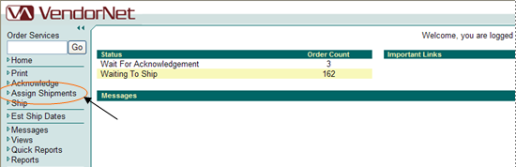

Click on Start Assignment
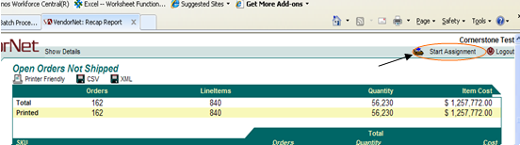

Select PO number you wish to ship from the list

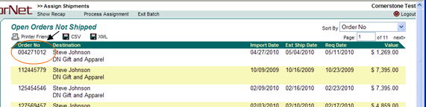

Enter total quantity you think will be on the shipment. (Clicking on the word quantity will auto fill your ship quantities complete) Once you have your quantities entered click on add cases.

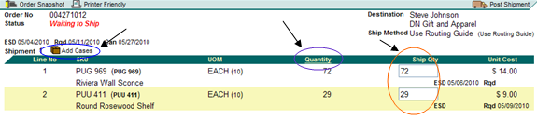

Enter in total number of cases shipping for each SKU then click Explode/Refresh

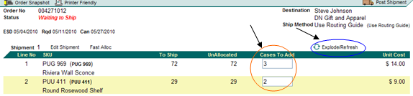

Verify case quantities are correct for each SSCC line listed. Make any modifications as needed. Then Explode/Refresh a second time.

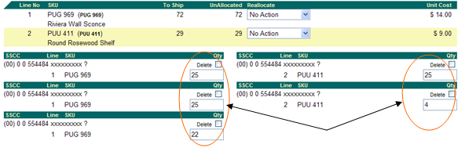
Confirm UnAllocated column goes to “0” If there is a number in the unallocated column this indicates that the quantities in the cases do not match the quantity you originally stated you were shipping. Make any corrections to the case quantities in the SSCC lines and click Explode/Refresh again and it will zero out.

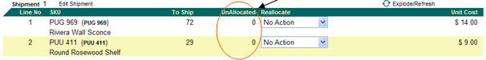

Click Process Assignment
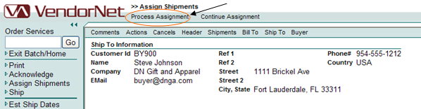

You will see an Assignment Batch recap. If everything looks correct click Update Assignment and confirm. Your UCC—128 labels will be printed at this time. Please Note: “THE ASN IS NOT CREATED WHEN YOU PROCESS AN ASSIGNED SHIPMENT” You must ship the order in VendorNet to send the ASN.. Failure to do so will result in non-compliance charges.

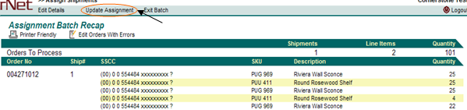

How to send an ASN from a previous assignment (No Changes needed).
Once your shipment is ready to ship you will need to ship confirm the order in VendorNet to create the ASN. If the original assignment was accurate and no modifications are required it can be accomplished in a few easy steps. If the original assignment needs to be changed (shipping short of original assignment) Please see how to modify an assignment and send ASN below)
To ship and send and ASN for a correct assignment click on Ship
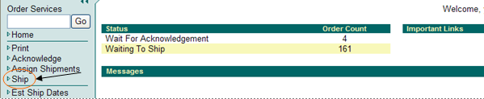
Then you can either enter your PO number in the Order services box and click Go or click on start shipping and select on the PO number.
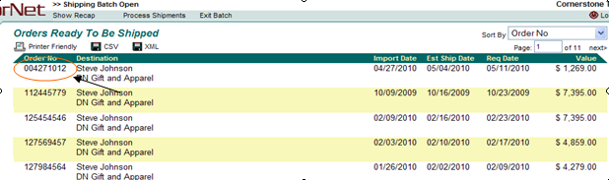

When the PO comes up now you will see the quantities are already filled for you. You will need to enter a tracking, BOL, or Container number into the Tracking No Field. If you are not aware of the number just enter the name of the carrier. Then click Process Shipments.

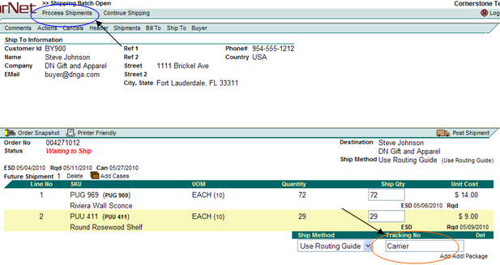
You will now see the shipping batch recap screen. Click on Update shipments, confirm it, and it will tell the shipping batch was successfully processed. This will send the ASN for your shipment.
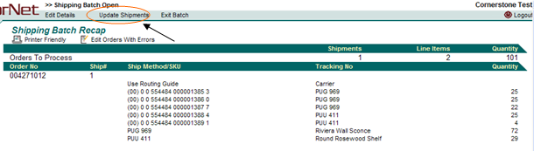
How to modify an assignment and send ASN
Follow the previous steps to get you into the order you need to modify ASN for until you get to this screen.
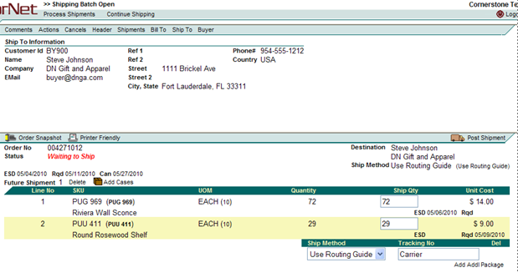
If you need to modify the ASN for this shipment for example on Line 2 of this order instead of shipping 29 we are only shipping 25 please update the quantity in that field to only the amount shipping and enter a tracking number. Then Click on Add Cases
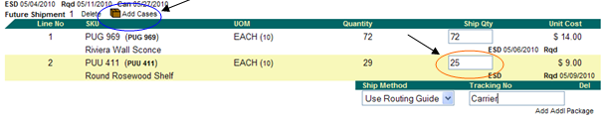
This will open the below screen that will give you the option of re-entering your case quantities. You will need to know which case numbers will need to be either modified or deleted for the ASN. In this example we are just going to delete the case with the 4 items in it. This can be done by clicking the delete checkbox for that case. Please note it will ask you to confirm whether or not you wish to delete that case. Please confirm if correct. You can also edit the case quantities for any cases that need changed if applicable. Once all the modifications are complete click Explode/Refresh
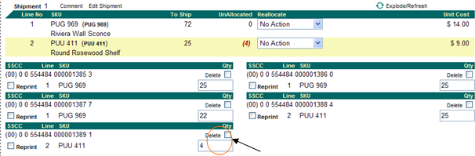

If everything is done correctly your unallocated column will go to “0”. You can then click on Process Shipments
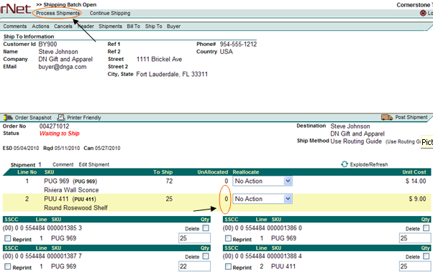

You will now see a shipping batch recap that will look similar to this. If everything is correct click on Update Shipments and confirm.
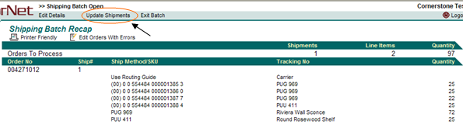

Once complete you will see a screen showing that it was successfully processed.

Please email vtg@cornerstonebrands.com if you have any questions.

